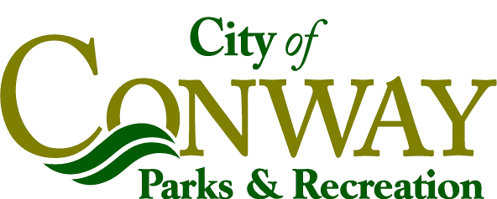
CONWAY PARKS AND RECREATION DEPARTMENT
General Rules and Regulations
Outdoor Facilities

The permit holder agrees to inform their participants and abide by all rules and regulations established by the City of Conway and its Recreation and Parks Department.

- Park facilities are never closed to the public. Reservations are for designated field use only.
- Parks & Recreation property and signage shall not be defaced or altered in any way.
- An additional fee will be charged for any vendors selling food or merchandise on City Park Property. The Reserving group shall know and abide by all local and state health department regulations concerning the preparation and/or resale of concession or other legal products. The concession stand/press box is not available for use. Areas will be designated by Parks and Recreation staff for Vendors. Designated Space size is 10’ x 15’. The Parks & Recreation Director shall approve any outside vendors setting up on Park Property. The City of Conway reserves the right to sell concessions and to lease vendor space to outside vendors.
- Fees & Charges: Deposit: $200.00.
Baseball/Softball $150.00 per day/per field
Football/Soccer $250.00 per day/per field
Light Fee for all fields: $30.00/hour.
Vendor Spaces: $50.00 per space per day.
Field maintenance: $20.00 per field
Facility Supervisor: $20.00 per hour.
- Based on the size and type of event, Police and/or EMS may be required at the renter’s expense.
- Alcohol and drugs are prohibited on City Park Property. Tobacco is discouraged.
- All guests must obey Police, Parks & Recreation Staff and others designated by the City to enforce rules while on park property. Disorderly conduct will result in immediate expulsion from the Park. Disorderly conduct includes, but is not limited to: Rude behavior, profanity, fighting, threatening behavior, public nudity, spitting, loud music or other noise. Littering of any kind is prohibited.
- Curfew on all fields shall be 12:00pm. Permission to waive curfew restriction must be approved by the Parks and Recreation Director
- Reserving Organizations/Personnel are responsible for any and all damages incurred to the facilities, which were a result of the scheduled event. You are also t liable for injury to person or persons using facility during the rental period. Lessee obligates itself to Indemnify and save harmless The City of Conway, its employees and its agents from any loss sustained by the Lessor as a result of, or in connection with, the use of the facility.
- Reserving Organizations/Personnel are responsible for cleaning the facility and bagging trash and depositing in trash cans on a daily basis. Failure to leave facility in original condition will result in loss of deposit and/or denial of facility reservations in the future. All trash shall be picked up daily by organizer.
- Under no circumstances can the facility be sub-leased at any time.
- Tournament Rental fee includes field preparation of all rented baseball/softball field(s) for that intended purpose one time per day. Field preparation consists of dragging and lining field only.Additional field preparation is available for a fee.
- Rental is for ball fields only. Admission may be charged at designated locations, however, access cannot be denied to those using the Park for exercise, shelters, Playgrounds, restrooms and other park amenities.
- Conway Parks and Recreation Department reserves the right to cancel an event at any time. In the event of poor weather, we reserve the right to cancel and/or postpone the tournament if it is deemed that unnecessary damage may occur to the playing field and complex. In the event of lightning, Site Supervisor reserves the right to postpone the tournament until it is safe to resume play.
- Designated Contact Person must be on site while tournament is in progress.
- Special requests are subject to the approval of the Parks & Recreation Director.

